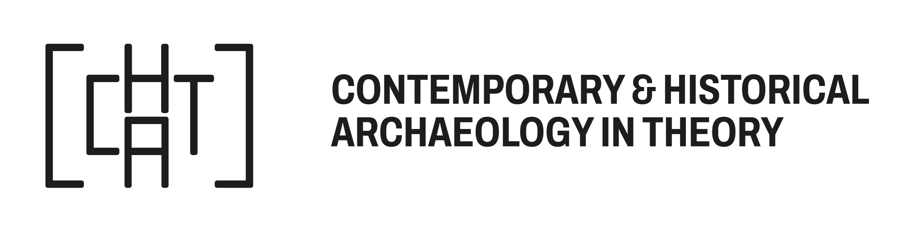
CHAT Botxo, Bilbao, 6-9 November 2025

About CHAT’s Bursary Award:
When funds are permitting, CHAT’s Standing Committee makes an annual bursary award to enable attendance at CHAT meetings. The 2025 award will be subject to a maximum of €300 for each successful candidate, up to a maximum of 5.
CHAT’s Standing Committee will prioritise the following groups: first time attendees, students, Non-EU/UK and Non-US participants and those on low-income. Applicants may be located in any part of the world. The Committee will not favour presentation over attendance. The award can be spent on registration/travel/hotel costs/childcare costs. Payments will be made before the meeting but are dependent on registration.
The deadline for receipt of applications is 15 October 2025 at 4pm CEST.
Please complete this form and once completed, please email the form to cont.hist.arch@gmail.com. We aim to notify applicants by the end of October 2025.

Title and full name:
Affiliation:

Address:

Email address:
Total funds requested from CHAT:
Please tell us why attendance at a CHAT meeting would be useful and any expected outcomes from attendance (in 300 words or less):

Applicant’s signature ________________________________________________ Date___________________

